DAS LECTURE CLASSES 2023 – 2024
The Devon Archaeological Society is offering the following programme of lecture courses for the current winter season. These courses are open to non-members as well as to members of the Society, so feel free to advertise them widely.
All four classes are available on Zoom, two of them also in person at Berkeley House.
Each course will consist of six sessions with a break part-way through each 2-hour session. There will be an opportunity to put questions to the lecturer, mid-way and at the end.
If you wish to take part in a class, you will need to register and pay in advance.
Details on how to access the class on Zoom will be sent to you on registration.
…………………….

WHAT’S NEW IN THE ROMAN WORLD?: Val Maxfield & Denise Allen
6 sessions: Fridays, starting November 10th; 10.30 to 12.30. In Berkeley House and on Zoom. Cost £48
In this course we shall be looking in part at new discoveries in the Roman world, and in part at sites long-known but only recently opened up to the visitor. The geographical scope of the course will take us from the heart of the Empire to its periphery, and we will look at both structures and artefacts.

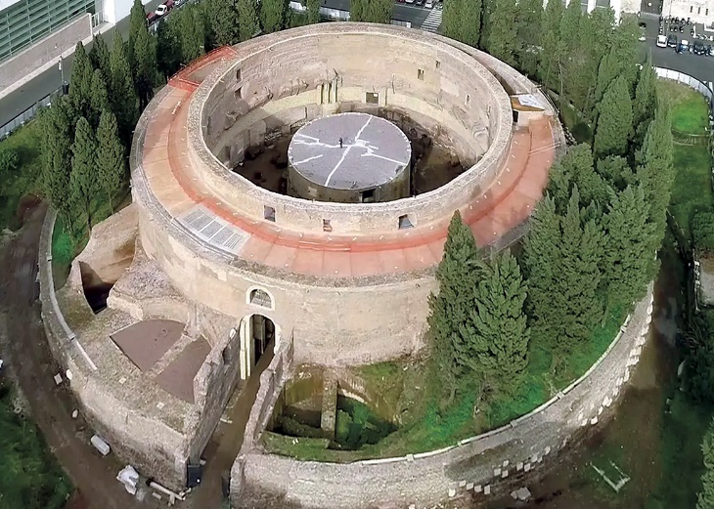 The tomb of Augustus
Denise Allen started in archaeology as an itinerant excavator in the 1970s, before completing a BA and PhD at Cardiff University. The latter was a study of Roman Glass from Britain, and this has been a constant specialism through more varied museum work and organising and leading archaeological tours around the world as a Director of Andante Travels, an archaeological travel company. She moved to Exeter, joined the DAS and now edits the newsletter, organises field visits and has taught classes on the Roman world. She is co-author of Roman Britain and Where to Find It.
Val Maxfield spent most of her archaeological career in the South West, retiring as Professor of Roman Archaeology at the University of Exeter. From this base she conducted survey and excavation from beyond the Antonine Wall in Scotland on the north-western periphery of the Roman Empire to the quarry settlements in the Egyptian desert on its south-eastern border; she has taught adult education classes and led field visits for Durham and Exeter Universities and, of more recent years for the DAS.

THE LEGACY OF BYZANTIUM: Geri Parlby
6 sessions: Mondays, 6th November to 11th December; 10.30 to 12.30. On Zoom. Cost £48
The Byzantine Empire and its great capital Constantinople influenced cultures across the globe for many centuries – from the Venetians, the Germanic tribes and kingdoms of the West to the Russians, Arabs, and Turks to the north and east. In this course we will be looking at how that influence first grew, how it outlived the fall of the empire in the 15th century and how its influence was reborn during the Byzantine revival in art and architecture in the 19th and 20th centuries.

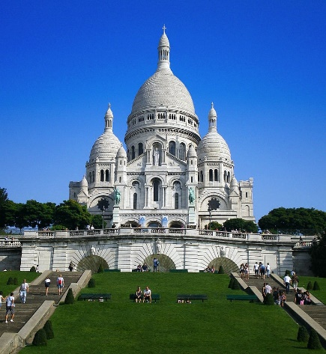 Le Sacré Coeur – Byzantium in Paris
Geri Parlby studied Art History at the Courtauld Institute and has a theology doctorate from Roehampton University where she is also an honorary research fellow. She developed the History of Art programme for Exeter’s Department of Lifelong Learning and has been lecturing for the past 15 years both in the UK and internationally. She is also principal lecturer on the South West Area Arts Society History of Art course and Chair of the Tavistock Heritage Trust.

ANCIENT LIBYA: FROM PHOENICIANS TO THE SEVERANS: Robert Morkot
6 sessions: Tuesdays, January 9th to February 13th.; 6.30pm to 8.30pm. On Zoom. Cost £48
The modern state of Libya, currently inaccessible to most visitors, has a rich archaeology and important place in the history of the Greek and Roman worlds. Lying opposite Crete and Greece, the eastern highlands were the focus of Greek settlement, Cyrene being the first and most significant. The western cities were relatively small, and in the sphere of Carthage, until the Roman conquest and the creation of the province of Tripolitania, after which they flourished and grew. The second century AD saw lavish rebuilding of the cities using marble and the local elites became active in Roman politics. One of those families, from Lepcis, produced a number of senators and consuls and, finally, the Emperor Lucius Septimius Severus.
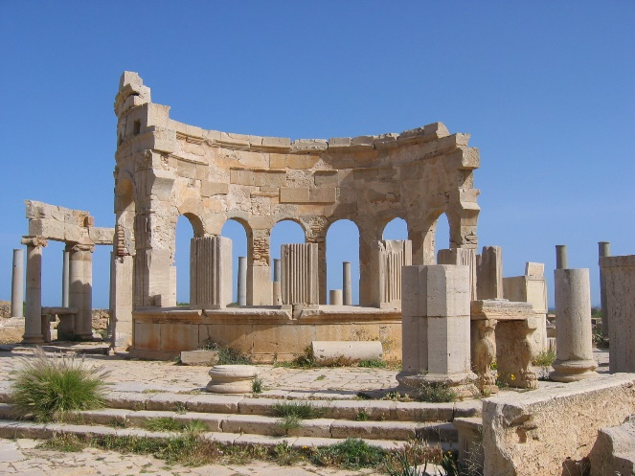 Lepcis Magna – Market place
Robert Morkot studied Ancient History and Egyptology in London and Berlin. His research interests are based in the Mediterranean and Noth-East Africa; he has been particularly involved with Egypt, Sudan and Libya, but has a broader involvement in the ancient Eastern Mediterranean/Near East. He travelled frequently to Libya between 1996 and 2010 and worked for two seasons on the Western Marmarica Coastal Survey which was the first to examine the region between Tobruk and the Egyptian border.

THE PICTS IN SCOTLAND: Derek Gore
6 sessions: Fridays 12th to 26th January (2nd Feb – break); 9th to 23rd February; 10.30 to 12.30. In Berkeley House and on Zoom. Cost £48
The Picts, known from Roman and Irish written sources, remained an archaeological mystery until about thirty years ago. Before that they were known largely from symbols on upright stones. Work by the University of Aberdeen using the latest archaeological techniques has now brought the Picts to life. The results of their ongoing research are already astonishing. We will look at the latest developments.

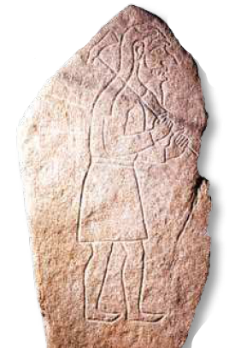Rhynie Man
Derek Gore was, for many years, a Teaching Fellow in the Archaeology Department at the University of Exeter, and before that was teaching University Lifelong Learning classes. He specialises in the archaeology of the Viking Age in Europe and Scandinavia and his publications include Vikings in the West Country.
……………………………..…………..

DAS CLASSES 2023 – 2024: BOOKING FORM
A BOOKING FORM MAY ALSO BE DOWNLOADED FROM THE DAS WEBSITE
http://www.devonarchaeologicalsociety.org.uk/downloads-and-forms/

PLEASE type or PRINT clearly

Name:

E-mail Address:
Postal Address:
Telephone No: Home Mobile
Member of DAS: Yes / No
I wish to book a place on the following course(s):
October – December 2023
WHAT’S NEW IN THE ROMAN WORLD? : £48
At Berkeley House / On Zoom Please delete as appropriate
THE LEGACY OF BYZANTIUM: £48 p.p. (Zoom only)

January – March 2024
ANCIENT LIBYA: FROM PHOENICIANS TO THE SEVERANS: £48 (Zoom only)
THE PICTS IN SCOTLAND: £48
At Berkeley House / On Zoom Please delete as appropriate
…
I enclose/will bring to the first class a cheque for £ made out to the Devon Archaeological Society
………………………….……………..

E-mail the completed form to val.maxfield@talktalk.net
Post cheques to: Val Maxfield, 42 Monmouth Street, Topsham, Exeter EX3 0AJ
Or Those attending in person may pay at the first class.
No receipts will be sent out, though they can be provided on request.
………………………….……………..

